Web site: https://batteryuniversity.com/learn/article/serial_and_parallel_battery_configurations

Serial connection of battery:

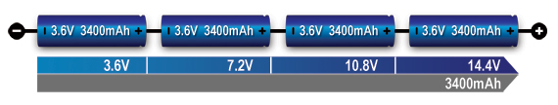

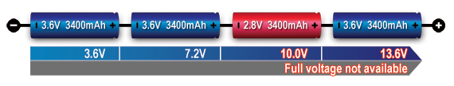

Any battery from connect lost to working there is a problem to connect battery in series. We must replace that battery to fully charge all the battery then only i can use it in the devices. otherwise the device is not work properly.

Connected to parallel:

 Increase capacity and extend runtime (i.e. amp/hours available) by connecting batteries in a Parallel Configuration.

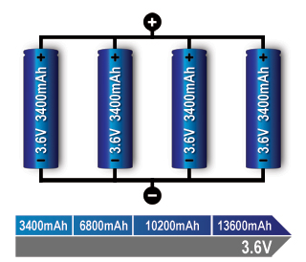

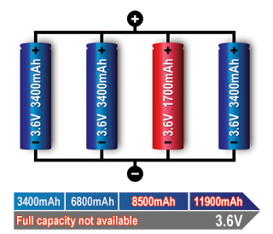

## **Figure 5: Parallel/connection with one faulty cell.** A weak cell will not affect the voltage but provide a low runtime due to reduced capacity. A shorted cell could cause excessive heat and become a fire hazard. On larger packs a fuse prevents high current by isolating the cell. Series/parallel Connection

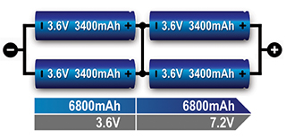

The total power is the sum of voltage times current; a 3.6V (nominal) cell multiplied by 3,400mAh produces 12.24Wh. Four 18650 Energy Cells of 3,400mAh each can be connected in series and parallel as shown to get 7.2V nominal and a total of 48.96Wh. A combination with 8 cells would produce 97.92Wh, the allowable limit for carry on an aircraft or shipped without Class 9 hazardous material